DeFuniak Springs Woman’s Club Memorial Scholarship 2026

Name________________________________________________

Address_______________________________________________

City, State, Zipcode_______________________________________________

Phone Number______________________________________________

Email Address_______________________________________________

Year graduated or GED ___________________________________
Where _______________________________________________

Signature________________________________ Date__________

I live in DFS______
I live in Walton Co but work in DFS______
I live outside Walton Co but work in Walton Co_______

+++++++++++++++++++++++++++++++++++++++++++++++++++++++++++++++++++++++++++
For Woman’s Club Use Only

Date Received______________ Assignment number_____________
(Please put number on each page of application)

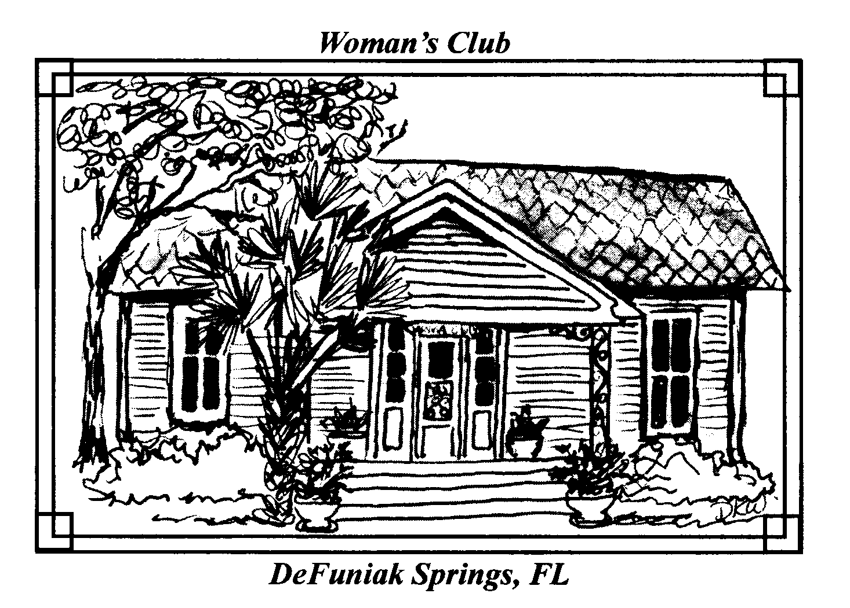
DeFuniak Springs
Woman’s Club
Since 1915

2026 MEMORIAL SCHOLARSHIP ANNOUNCEMENT
AWARD DATE: JULY 15, 2026

Are you furthering your education at Technical/Vocational school or University?

Apply now for a $1000 scholarship from the DeFuniak Springs Woman’s Club

To Apply
- Applicants must complete and submit the attached application
- Applicants must live or work in Walton County, however, priority will be given to DeFuniak Springs residents.
- Applicants must have a high school diploma or GED equivalent.
- Email or mail with a postmark on or before June 1, 2026.
Email: dfswomansclub@gmail.com
Mail: DFS Woman’s Club, 214 Oaklawn Drive, DeFuniak Springs, FL 32435

About the DeFuniak Springs Woman’s Club Memorial Scholarship

The DFS Woman’s club is proud to announce its’ second annual scholarship process.
This year we will offer a scholarship to a woman who will be attending either a Technical/ Vocational School, College/University, or seeking Professional Development/Continuing Education Credits. The scholarship will be open to individuals without regard to marital status or full time or part time enrollment. The scholarship is available to women seeking to further their education so that they may join or return to the workforce.
Scholarship award money is paid directly to the school upon proof of the recipient’s enrollment. It is the recipient’s responsibility to provide proof of enrollment.
The recipient will be awarded an honorary one-year membership to the Woman’s Club and invited to attend meetings and share the progress of their journey. Meeting attendance is not a requirement of the scholarship.

PERSONAL INFORMATION

All personal information should be on the cover sheet only so anonymity can be preserved during the judging process.

EDUCATION STATUS

What degree or program of study are you pursuing?

List the names of the institutions to which you have applied; indicate ones to which you have been accepted.

FINANCIAL AID

Have you applied for financial aid (student loans, grants, work-study)? Yes No
Type of Aid_______________________________________________________________

Are you currently a recipient of financial assistance from other sources such as trusts, grants, scholarships, agencies, or Bright Futures? Yes No
If yes, List:

Explain any special personal, family, or financial situation you believe merits consideration in the award of this scholarship.

The DeFuniak Woman’s Club is a Community Service Organization. Please share with us how you have participated in a community service project or event, either in the past or currently.

If you do not have any community service experience, please share how community service may be important to you in the future.

FUTURE GOALS

What are your education and career goals and how will this award help you achieve these goals? 300 words or less, emailed or mailed.

The information provided on this application is complete and accurate to the best of my knowledge. I understand that the information provided herein will be used only for scholarship selection purposes.

I understand the scholarship funds will be awarded to the Vocational/Technical School, College, or University, and failure to register and attend will result in the forfeit of the scholarship. The funds must be used within one year of the award notification.

I understand that I am responsible for any additional expenses in this program that may not be covered by financial aid.

I understand that I am expected to have good attendance, make adequate progress in my classwork, lab/shop experiences and internship experiences (as applicable) to remain in good standing with the DeFuniak Springs Woman’s Club.

By signing the cover page, I affirm the application was completed by the applicant.

